Rohan Malipeddi 1

AP Physics C: Mechanics

19 August 2022

AP Physics Lab #1

* Determine the radius in cm of the different sized disks.

1. Measure the disk’s diameter using a ruler and apply the 2-5-8 rule for the last uncertain digit.
2. Divide the measured length by 2.

* Determine the mass, in g, of the different sized disks.

1. Measure the mass of each disk using a scale.

* Determine the height (thickness) in cm of the disk material. (*DensityAluminum= 2.70 g/cm)

1. Use the density equation to find the height. Height = (density *Area of the disk) / mass
2. Do this for all the disks

Pre-experiment question:

1. What is the precision of the meterstick used? Explain how you know using the data you found.

The precision of the meterstick used is to the 100th of a cm. I know this because I measured exactly to the last millimeter (10th’s place) and then used the 2-5-8 rule for the last uncertain digit (100th’s place)

Title: Relationship between mass and radius table

|  |  |  |  |
| --- | --- | --- | --- |
| Circle # | Radius (cm) | Mass (g) | Linearized Values (cm2 or r^2) |
| 1 | 6.80 | 0.845 | 46.240 |
| 2 | 5.155 | 0.488 | 26.574 |
| 3 | 3.900 | 0.300 | 15.210 |
| 4 | 3.100 | 0.222 | 9.610 |
| 5 | 2.355 | 0.078 | 5.546 |

Graph #1- Radius vs Mass

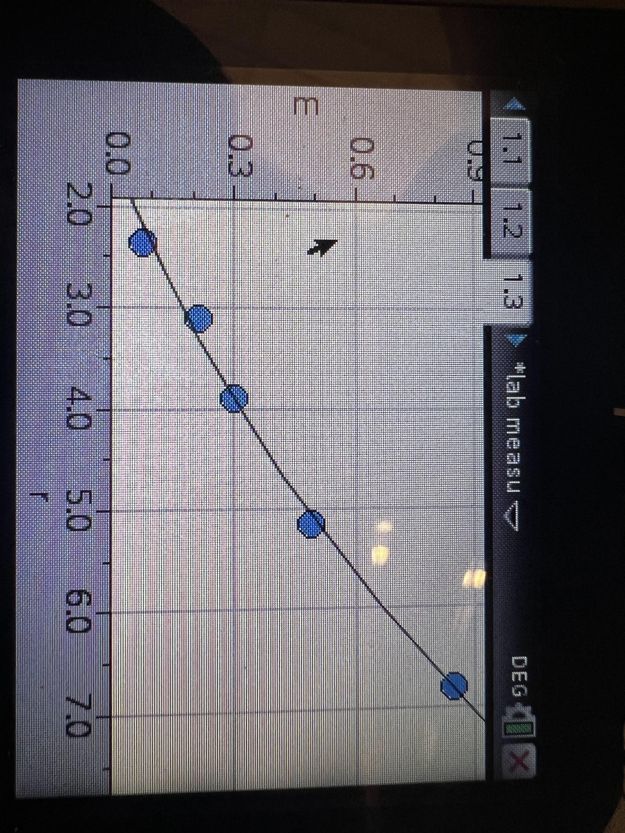

Non-linear or quadratic graph showing the relationship between mass(g) of disks (y axis) and radius(cm) of disks (x axis), assuming uniform thickness.

Equation:y= 0.012463x^2 + 0.053317-0.099991

Graph #2- Linearized Graph (Radius)^2 vs Mass

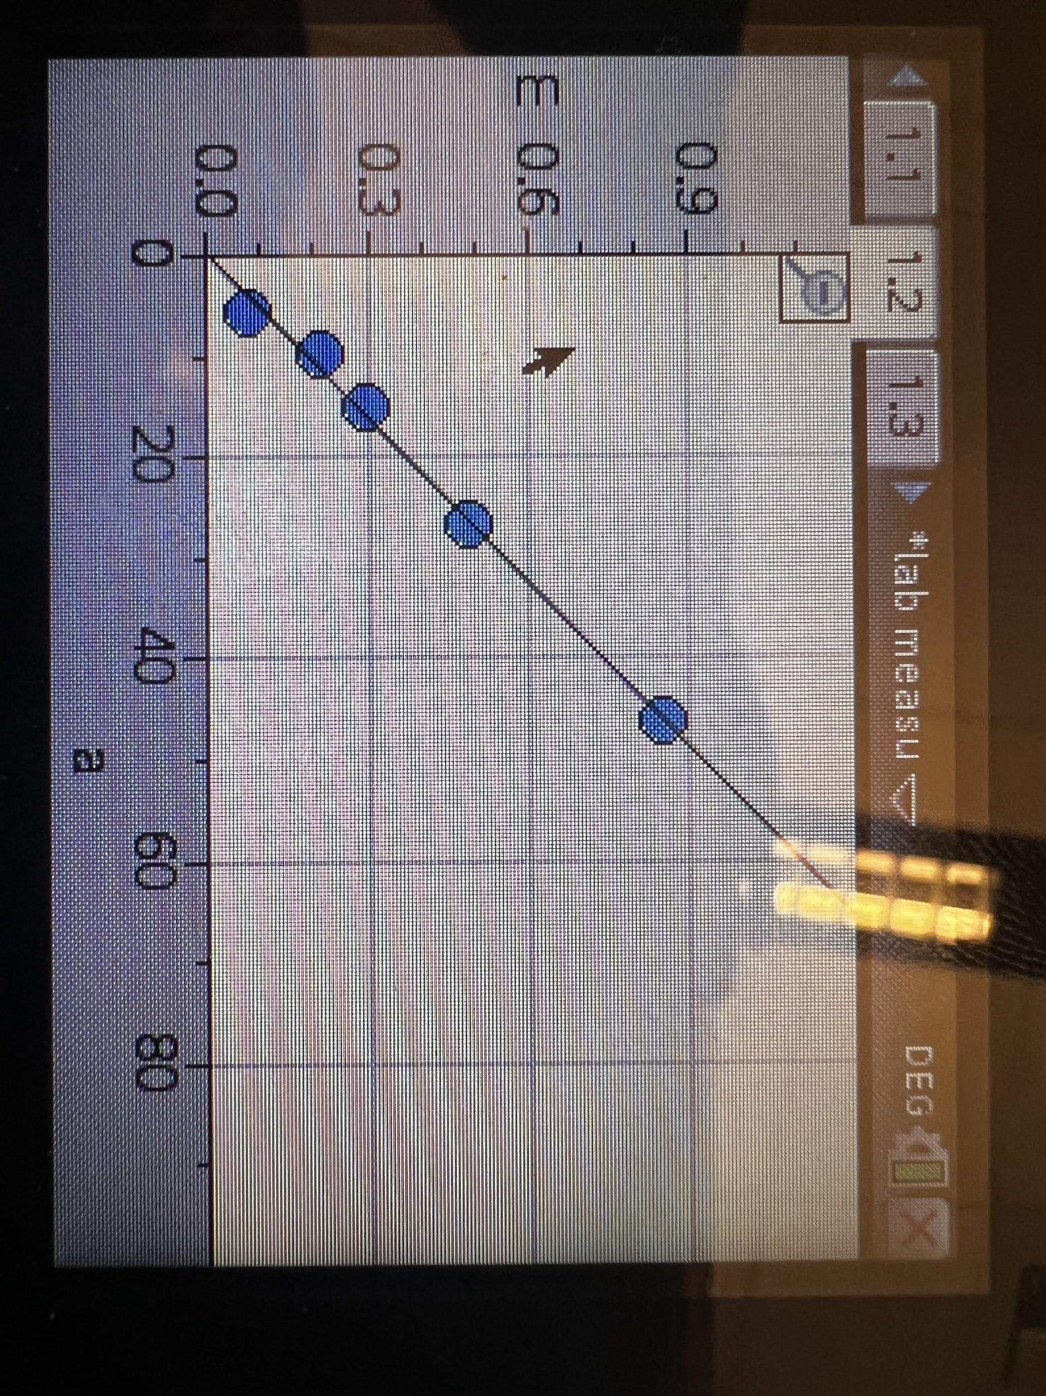

This is a linearized graph with radius squared(cm^2)(x-axis) and mass(g)(y-axis).

How did we linearize our graph? From the original table , we squared the radius and kept the mass same because we found that the original graph of non-linearized data looked very similar to a parabola and so figured out that, if we square the radius, the graph becomes linearized.

Best fit line equation: y=0.010141+0.018138x

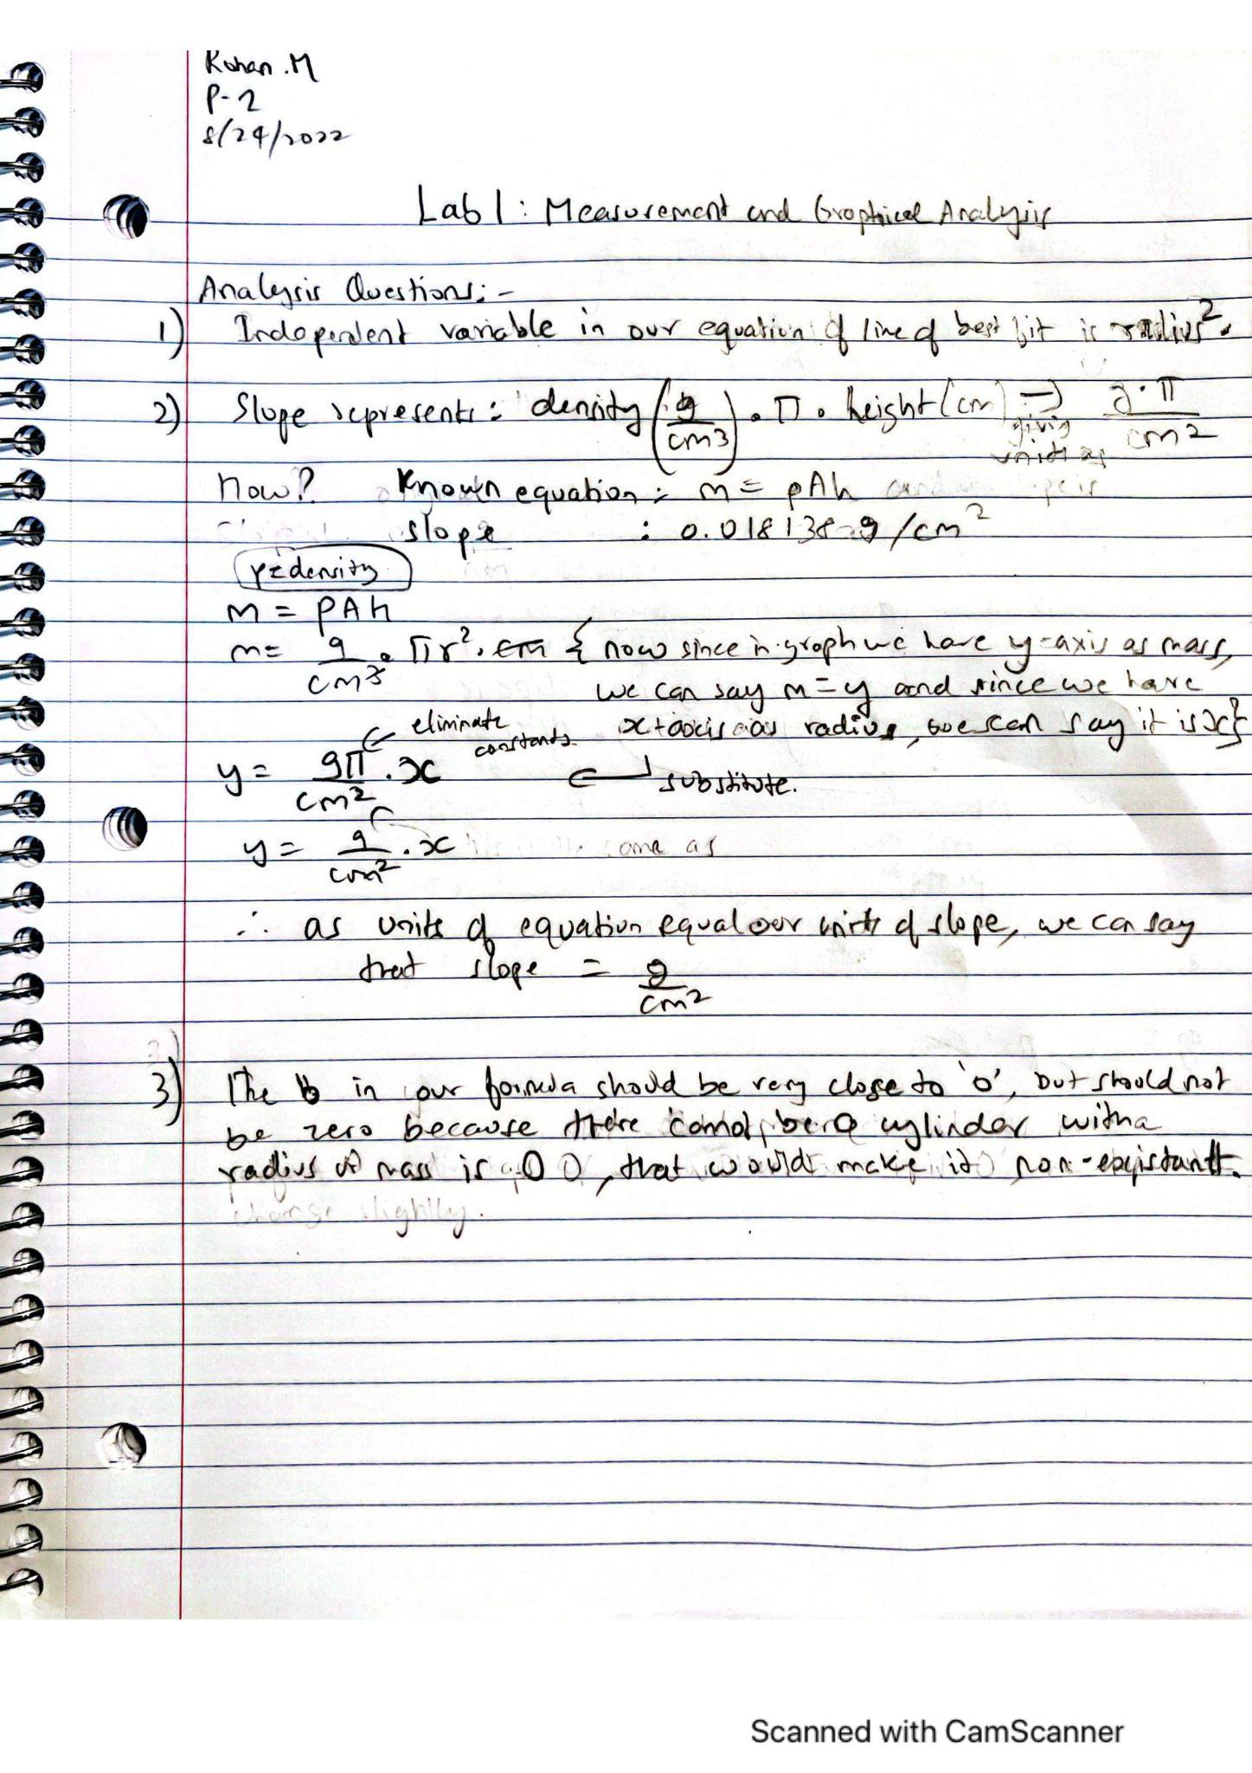

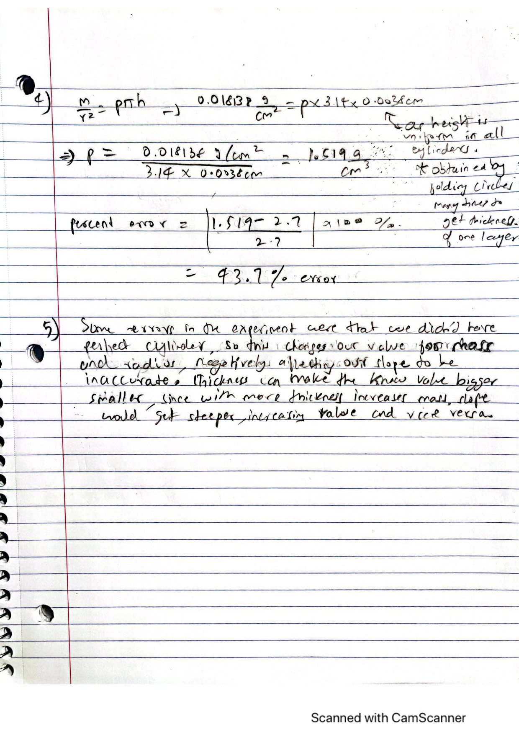

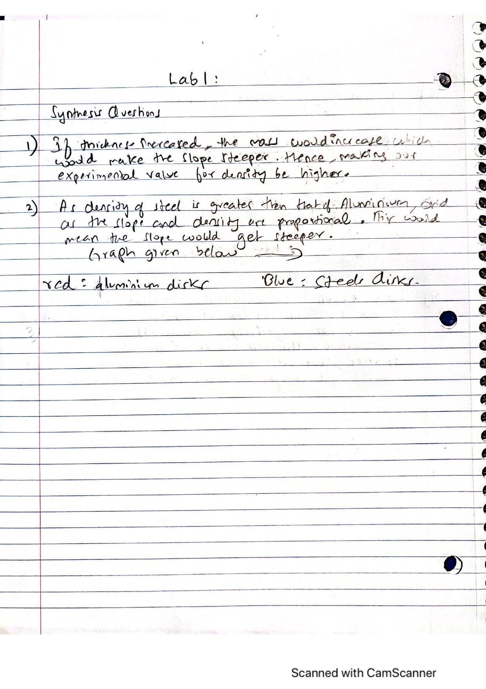

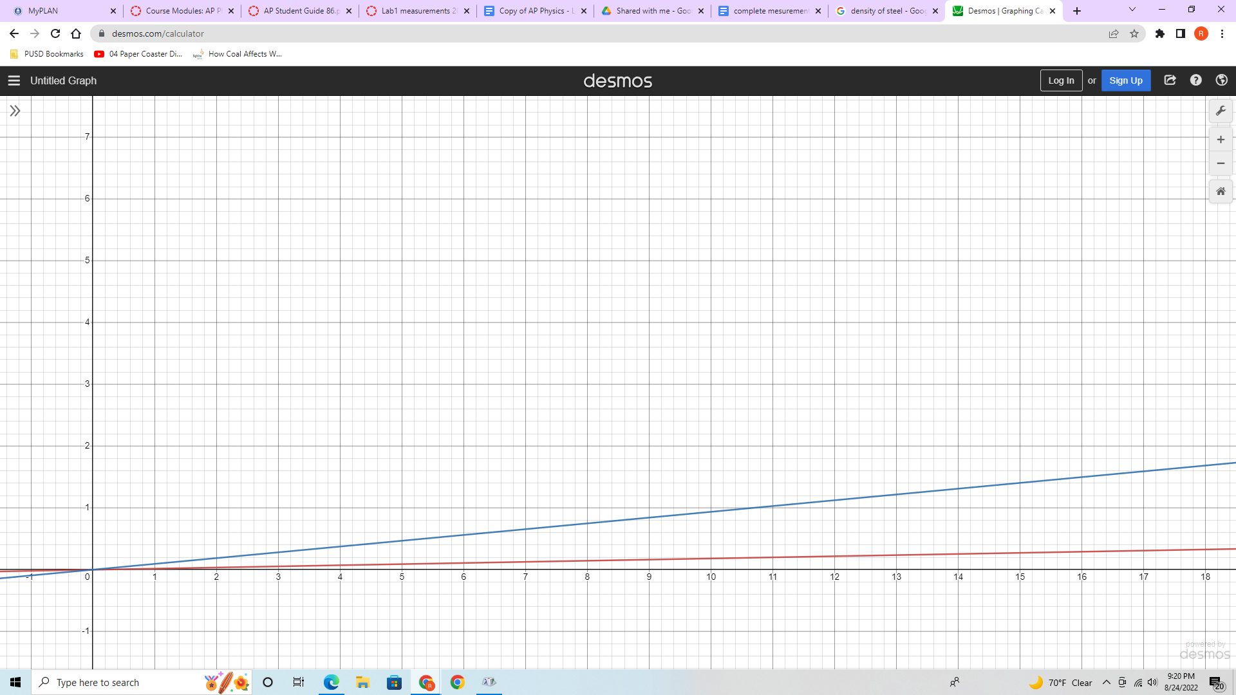

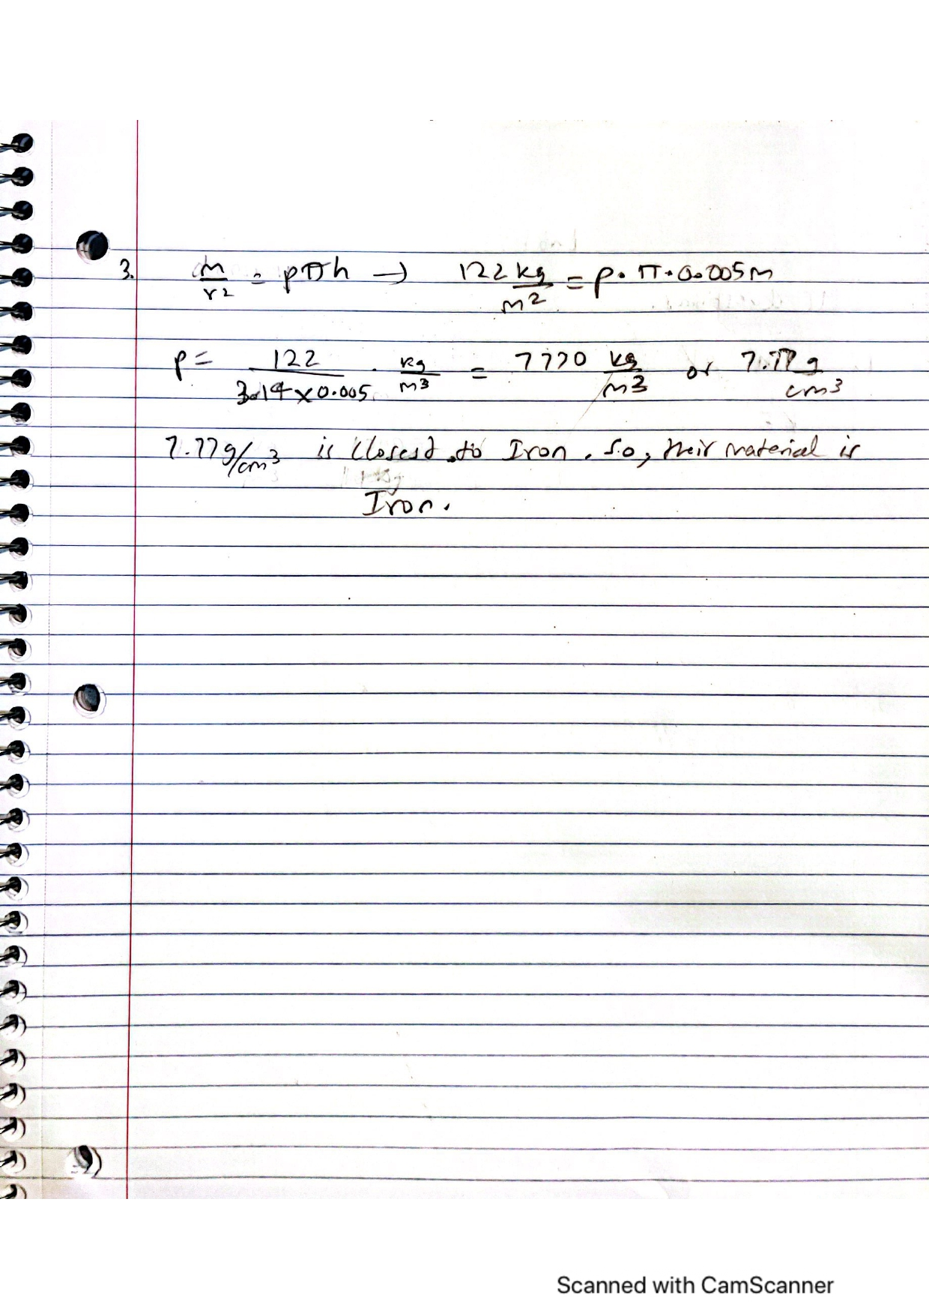

MC Question:

1. E
2. B
3. C